Angular seed -2

# Clone the repository from GitHub

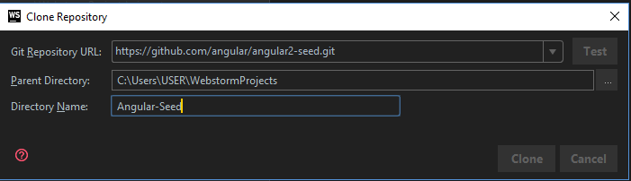

# Install all the global dependencies

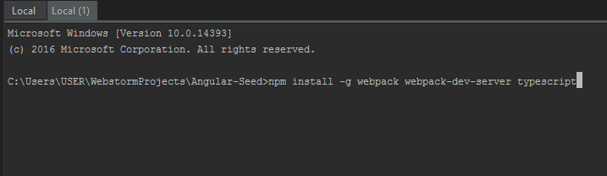

# Install common dependencies

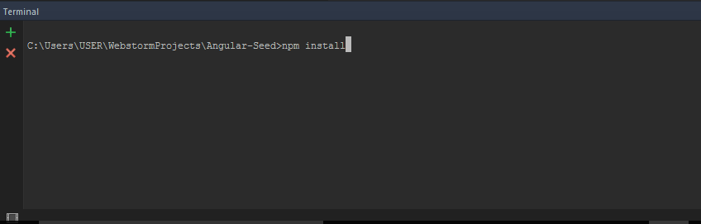

# Start the dev server

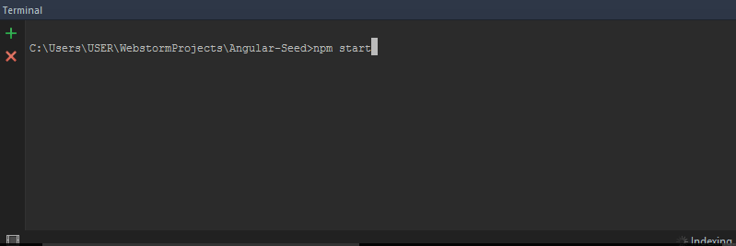

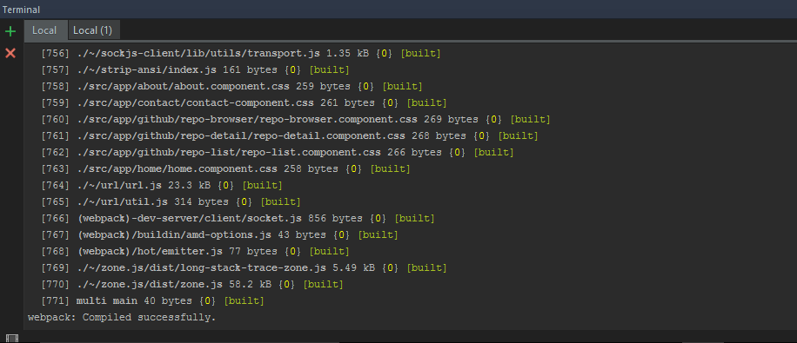

# Output

